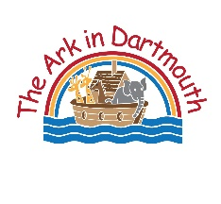 | The Ark in Dartmouth Winter snack menu 2026
 | MONDAY | TUESDAY | WEDNESDAY | THURSDAY | FRIDAY
Morning snack | Fruit and veg selection Porridge with banana | Fruit and veg selection  Toast and spread | Fruit and veg selection  Crumpets | Porridge with banana | Fruit and veg selection  Bagel
Afternoon snack | Fruit and veg selection  Toasted muffin | Fruit and veg selection  Blueberry oatbar | Fruit and veg selection  Rice cracker with soft cheese | Fruit and veg selection  Pitta with soft cheese | Crackers with cheese and pinapple
Tea | Ham and cheese pinwheels | Tomato pea and sweetcorn pasta | Scrambled egg on toast | Ham and courgette fritter | Ham and egg omelette
Occasionally menu choices will be swapped around. The overall balance will remain the same. This menu has been put together using the voluntary food and drink guidelines for early years settings – Eat Better Start Better. For further information please see a member of staff.

