 | 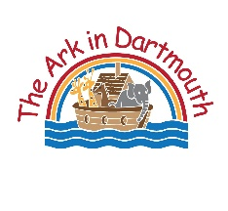 | The Ark in Dartmouth Winter Term menu 2026
 |  | MONDAY | TUESDAY | WEDNESDAY | THURSDAY | FRIDAY
Week 1 | Week beginning  5/01  19/01  2/02  16/02  2/03  16/03  30/03 | Spaghetti bolognese with lots of hidden veg  Fresh homemade Waffles with berries | Roast chicken, Roast potatoes, yorkshire pudding and broccoli  Fruit Salad | Tuna and sweetcorn slice with carrot sticks  Homemade apple crumble | Jacket potato with tuna and sweetcorn  Homemade fruit muffin | Ham and pea mac and cheese  Greek Yoghurt with sugar free cereal
Week 2 | 12/01  26/01  9/02  23/02  9/03  23/03 | 3 bean chilli (no chilli) with rice  Homemade fruit muffin | Homemade carrot based pizza with crispy potatoes and cucumber sticks  Banana Pudding | Mince and hidden veg in a tomato sauce topped with mashed potato  Fruit Salad | Homemade Chicken pie, mash potato and carrots  Greek Yoghurt with sugar free cereal | Cod and homemade chips with peas  Apple and Carrot bake
Occasionally menu choices will be swapped around. The overall balance will remain the same. This menu has been put together using the voluntary food and drink guidelines for early years settings – Eat Better Start Better. For further information please see a member of staff.

